Cranes Loads

Middle span Crane loads :

Crane capacity = 32t , span = 38m , wheel spacing = σ = 5.8 m  
Max Wheel load = Pmax = 33 t , Min wheel load = Pmin = 9.4t

V­­LL **max =** Pmax ­* ( 1 + ( S – σ ) / S ) = 35 t , VLL min ­= 10 t , V­DL ­= 0.2 t/m\ * 6m / 2 = 0.6 t

BFmax = 1/7 * 2 * Pmax = **10t**  , BFmin = 2.7 t

H­max = 0.1 VLL = **0.4 t** , Hmin = 1t …… Taken **1.9t**

Vtmax = **1.25** VLL + VDL = 45 t …. Taken **40t** , Vtmin = 14t …. Taken **19t**

**Crane Grider :**

Assume that girder resist only one wheel as wheel spacing is 5.8 m

moment due to load = 1.25 x ( Pmax x girder length / 4 ) = 61.5 t.m -> 1.25 impact factor

moment due to ow = 0.1t/m x 62 / 8 = 0.45 t.m

Mx = total moment = 62 t.m

assume web dimensions = 300 x 10 mm , flange thickness = 20 mm

web depth / web thickness = 30 < 190 / fy0.5 , safe for local buckling

required inertia = 53142 cm4

flange length = 400 mm , flange length / 2x thickness = 10 < 21 / fy0.5…. Safe for local buckling

allowable shear = web area * yield stress = 30 x 1 x 2.1 = 60 tons > Pmax  **…….safe**

My = Hmax x girder length / 4 = 0.4 x 6 / 4 = 0.6 t.m -> resisted by upper plate only

Plate inertia = 403 x 2 /12 = 10666 cm4

My allowable = stress x Ix /y = 2.1 x 10666 / 20 = 1120 t.cm = 11.2 t.m …… safe

Deflection calculations :

Deflection = P L3 / 3EI = 0.22 cm

Allowable deflection = span / 800 = 0.75 cm …….. safe

**Left span crane loads :**

Capacity = 10t >>>>> 16 t , crane span = 24 m , wheel spacing = σ = 4.56 m

CTG span = S = 6m  
**Max wheel load = Pmax = 8 t**

**Minimum Wheel load = Pmin** = 2.4t

**Max Lateral shock =** 0.1 * 8t = 0.8t ….. taken **1.15 t**

**Min Lateral shock =** 0.31 t **……** taken **0.7t**

VDL = 0.2t/m\ * 6m /2 = 0.6t

VLL = Pmax + Pmax * ( S - σ ) / S = **10 t**

Vtmax = 1.25 VLL + VDL = 13t …… taken **11.5t ,** Vtmin = 3.6t ….. taken **7.2t**

BFmax = 2/7 * Pmax = 2.3t …. Taken **3.3t**

**Crane Grider :**

Assume that beam resists only one crane wheel as wheels spacing is 4.56 m

Max moment = 0.1t/m * 62 / 8 + 8 * 6 /4 = 12.5 tons

web dimensions = 200 x 10 , web depth / thickness < 190/fy0.5 …… safe for local buckling

use flange thickness = 20 mm

required inertia = 7143 cm4

flange length = 12 cm , flange length / thickness < 21/fy0.5 … safe

deflection = P L3 / 3EI = 0.4 cm

allowable deflection = span / 800 = 0.75 cm ….. . safe

**required bracket :**

moment = Pmax x (1 + 4.56 / 6 ) x 0.3 x 1.25 = 5.3 t.m

use web dimension = 150 x 10 mm , flange thickness = 10

required inertia = 2145 cm4

flange length = 15 cm -> flange length / 2 x thickness = 7.5 < 21 /fy0.5 ….. safe for L.B

Corrugated Sheets

roof Corrugated sheets :

**Middle span Live load** = 60 – 200/3 * tan(α) = 60 – 200/3 * 0.06 = 56 kg / m2

* use corrugated sheet of allowable live load = 100 kg / m­2 , span **2 m**  
  use **continuous** corrugated sheet of thickness **0.55 mm**
* Ow Dead Load = 5.25 kg/m2
* **Total load Gravity** = 5.25 + 56 = **61.25** kg/m2
* **Wind Load** ( wind side )= q * c * K * a / cos(angle) = 50kg/m2 * -0.8 * 1.15 / cos(tan-1(1200/20000) ) = -**46 kg/m2**
* **Wind Load** ( wind opposite side )= q * c * K * a / cos(angle) = 50kg/m2 * -0.5 * 1.15 / cos(tan-1(1200/20000) ) = -**29 kg/m2**

**side spans live load** = 60 – 200/3 * tan(α) = 60 – 200/3 * 0.1 = 53 kg / m2

* use corrugated sheet of allowable live load = 100 kg / m­2 , span **2.5 m**
* use **continuous** corrugated sheet of thickness **0.7 mm**
* ow = 6.66 kg/m2
* **Total load =** 6.66 + 53 = **60** kg/m2
* **Wind Load** = q * c * K * a / cos(angle) = 50kg/m2 * -0.8 * 1.15 / cos(tan-1(1200/12500) ) = -**46 kg/m2**
* **Wind Load** ( wind side )= q * c * K * a / cos(angle) = 50kg/m2 * -0.5 * 1.15 / cos(tan-1(1200/20000) ) = -**29 kg/m2**

side Corrugated sheets :

**level > 10 m ,** Span = 2 m

* wind load ( wind direction ) **=** Ce * K * q = 0.8 * 1.15 * 50 = 50 kg / m2 ,
* Wind load ( opposite wind direction ) = **=** Ce * K * q = -0.5 * 1.15 * 50 = -**32 kg / m2**  ,
* Ow = 4.75 kg/m2 (vertical load)
* Use **continuous** corrugated sheets for all side of thickness **0.5 mm**

**level < 10 m ,** Span = 2.5 m

* Use corregated sheet of allowable load = 50 kg / m2
* **wind load** ( wind direction ) **=** Ce * K * q = 0.8 * 1.0 * 50 = 40kg/m2
* **wind load** ( wind opposite dir. ) **=** Ce * K * q = -0.5 * 1.0 * 50 = -25kg/m2
* Ow = 4.75 kg/m2 (vertical load)
* Use **continuous** corrugated sheets for all side of thickness **0.5 mm**

Corrugated Sheets Summery :

* Use continuous in **middle span** roof corrugated sheets of **0.7 mm**
* Use continuous in **side spans** roof corrugated sheets of **0.55 mm**
* Use continuous in **side corrugated** sheets of **0.50 mm**

Mezanin

Flooring = 200 kg/m2

Storage Floor Live Load = 500 Kg/m2

Management Floors Live Load = 400 Kg/m2

Walls distributed load = 200 kg/m2

Deck span = 2.50 m

Use Metal Deck thickness = 1.2 mm

For **Storage Floor** Use concrete thickness = 8 cm

* concrete load = 2500 kg/m3 * 0.08 = 200 kg/m2
* total dead load = 600 kg/m2
* total live load = 500 kg/m2
* total working load = 1100 kg/m2
* Total ultimate load for storage floor = 1.4 * (200 + 200 + 200 ) + 1.6 * 500 = 1640 kg/m2
* Allowable load for storage floor = **1758 kg/m2**

For **management Floor** Use concrete thickness = 7 cm

* concrete load = 2500 kg/m3 * 0.08 = 200 kg/m2
* total dead load = 575 kg / m2
* total live load = 400 kg/m2
* total working load = 975 kg/m2
* Total ultimate load for mang. floor = 1.4 * (200 + 175 + 200) + 1.6 * 400 = 1445 kg/m2
* Allowable load for management floor = **1542 kg/m2**

Mezanin Summery :

Use Metal Deck of **1.2 mm**

For Management Floors , Concrete Thickness = **7 cm**

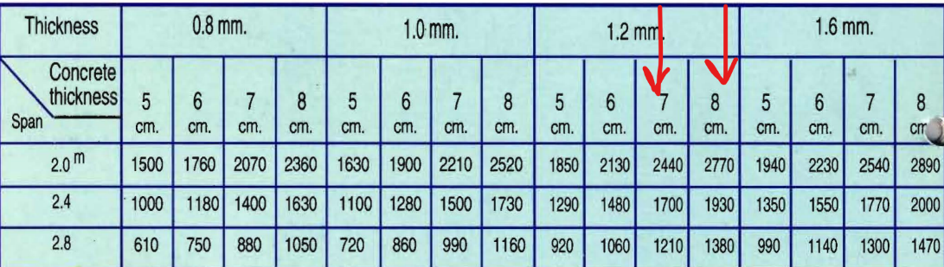For storage Floor , Concrete Thickness = **8 cm**

**Roof Purlins Design**

**Purlins Middle span :**

* **Live** load = 56 kg/m­2 * 2m = **112 kg/m**
* Ow = 25 kg/m
* **Dead** load = 5.25 kg/m2 * 2m + 25kg/m = **30.5** kg/m
* Dead Load Reactions = 30.5kg/m * 6m / 2 = 91.5 kg = 0.092t
* Live load Reactions = 112kg/m * 6m / 2 = 336 kg = 0.34t
* Total load Reactions = 427.5 kg = 0.43 t
* Total load = 30.5kg/m + 112kg/m **= 0.15 t/m\ …….. critical purlins design load**
* Wind Load ( wind direction ) = -46kg/m2 * 2m = -92 kg/m\  = -0.1 t/m\
* Wind Load ( opposite direction ) = -29kg/m2 * 2 = -0.06 t/m\
* Wind Load ( wind direction ) Reaction = -46kg/m2 * 2m * 6m /2 = -0.28t
* Wind load (opposite wind dir) Reaction = -29kg/m2 * 2m * 6m /2 = -0.18t
* Frame span = 6m -> Max Moment = 0.15 * 62 / 8 = 0.68 t.m = 68 t.cm

**Purlins Side Spans :**

* **Live** Load = 53 kg/m2 * 2.5m = **132.5 kg/m**
* Ow = 25 kg/m
* **Dead** Load = 25kg/m + 6.66kg/m2 * 2.5m = **41.65 kg/m**
* **Dead** load **Reactions** = 41.65kg/m * 6m / 2 = 125 kg = 0.125 t @ 2.5m span
* **Live** load **Reactions** = 132.5kg/m * 6m / 2 = 397.5 kg = 0.4t @ 2.5m span
* Total load Reaction = 0.525t
* Total Load = 41.65 kg/m + 132.5 kg/m **= 0.18 t/m\ …... Critical purlins design load**
* Wind Load ( wind direction ) = -46kg/m2 * 2m = -92 kg/m\  = -0.1 t/m\
* Wind Load ( opposite direction ) = -29kg/m2 * 2 = -0.06 t/m\
* Wind Load ( wind direction ) Reaction = -46kg/m2 * 2.5m * 6m /2 = -0.35t
* Wind load (opposite wind dir) Reaction = -29kg/m2 * 2.5m * 6m /2 = -0.22t
* Frame span = 6m -> Max Moment = 0.18 * 62 / 8 = 0.81 t.m = 81 t.cm ,
* Zx = 57cm3

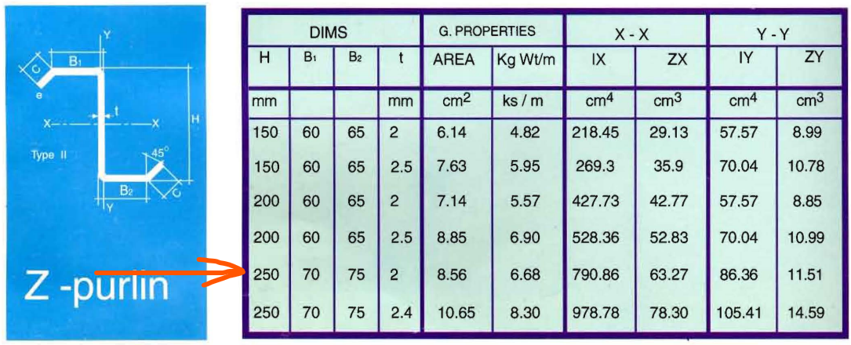

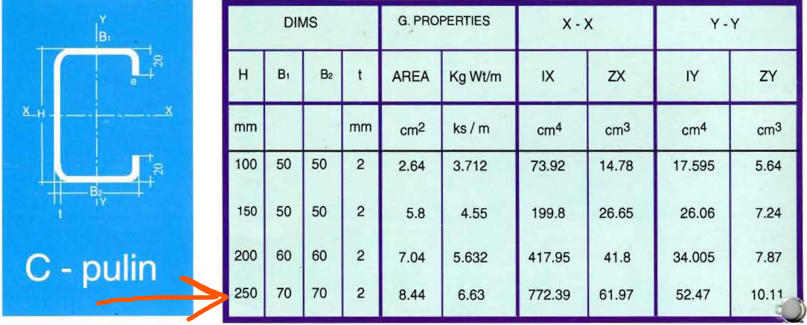

**Side Purlins**

**Side Purlins Beams < 10.00 m level:**

* Wind Lateral Load (wind direction) = 40kg/m2 * 2.5m = 100kg/m **= 0.1 t/m …..critical purlins design load**
* Wind Lateral Load (opposite wind dir) = -25kg/m2 * 2.5m = 63kg/m = 0.063 t/m
* Vertical load = corrugated sheet ow + purlin ow = 4.75 kg/m2 * 2.5m + 25kg/m = 36.9kg/m **= 0.04 t/m\**
* Lateral Reaction (wind direction) = 0.1t/m * 6m / 2 = 0.3t
* Later reaction (opposite wind dir ) = 0.063t/m * 6m /2 = 0.19 t
* Vertical Reaction = 36.9kg/m * 6m / 2 = 0.11t
* Max moment = 0.45 t.m = 45 t.cm ,

**Side Purlins Beams > 10.00 m level:** ( design like purlins at level below 10.00m)

* Wind Lateral Load (wind direction) = 46kg/m2 * 2 m = 92kg/m = 0.092 t/m
* Wind Lateral Load (opposite wind dir) = -32kg/m2 * 2 m = 64kg/m = 0.064 t/m
* Vertical load = corrugated sheet ow + purlin ow = 4.75 kg/m2 * 2 m + 25kg/m = 35kg/m **= 0.035 t/m\**
* Lateral Reaction (wind dir) = 0.092t/m * 6m / 2 = 0.28t
* Lateral Reaction (opposite wind dir) = 0.064t/m * 6m / 2 = 0.19t
* Vertical Reaction = 35kg/m * 6m / 2 = 0.11t
* Moment = 0.092 t/m * 62 / 8 = 0.414 t.m = 41 t.cm
* Zx = 41 t.cm / 0.58*fy = 41/ 1.4 = 29.3 cm3

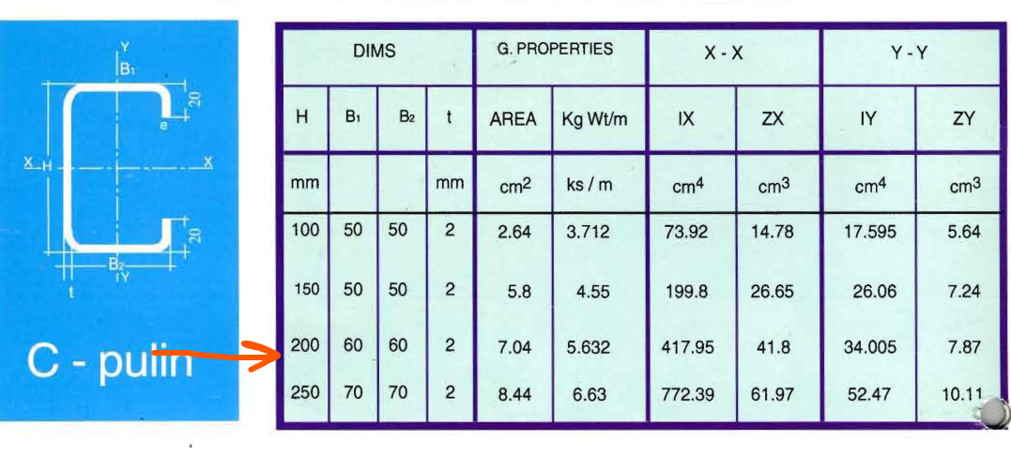

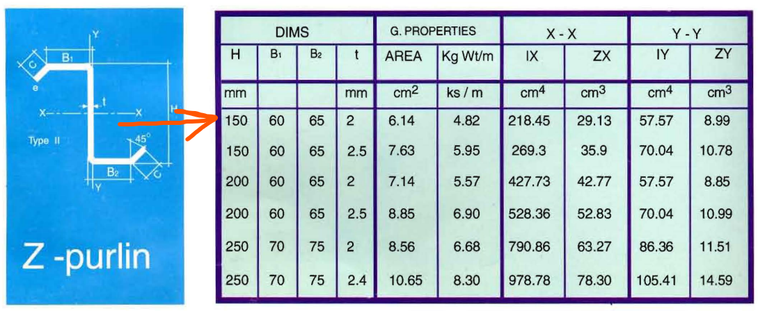

**Beams load**

**Mezanin storage floor main beams (in plan)** (using metal deck allowable load ) :

* Dead load from secondary beam = 1.6t/m * 6m = 9.6 t , secondary beams from one side , @2.5m spacing ( 6m is instead of 2* span /2 = 2 * 6 / 2 = 6m )
* Live load from secondary beam = 1.25t/m * 6m = 7.5 t , secondary beams from one side , @2.5m spacing
* Total loads = 9.6 + 7.5 = 17 tons @ middle of span

**Mezanin management floor main beams** (using metal deck allowable load ) :

* Dead load = 1.55t/m * 6m = 9.3 t, secondary beams from one side , @2.5m spacing
* Live load = 1t/m * 6m = 6 t , secondary beams from one side , @2.5m spacing
* Total load = 16 tons

**Mezanin Storage Floor Secondary Beams ( out of plan beams ) :**

* Dead load = 0.6t/m2 * 2.5m = 1.5 t/m
* Total Live load = 0.5t/m2 * 2.5m = 1.25 t/m
* ow = 100 kg / m
* Total Dead load = 0.1t/m + 1.5t/m = 1.6 t/m
* Total reaction = 8.5 tons
* Total Load = 2.85 t/m
* Moment = 12.8 t.m
* Required inertia = 12495 cm4
* Web depth = 380 mm
* Web thickness = 10 mm
* Flanges thickness = 10 mm
* Flanges width = 100mm

**Mezanin Management Floor Secondary Beams (out of plan) :**

* Dead load = 0.58t/m2 * 2.5m = 1.45 t/m
* Ow = 0.1 t/m
* Total Dead load = 1.55 t/m
* Live load = 0.4t/m2 * 2.5m = 1 t/m
* Total Load = 2.55 t/m
* Total reaction = 8 tons
* Moment = 11.5 t.m
* Web dim. = 340 x 10 mm
* Flange thickness = 10 mm
* Required inertia = 10130 cm4
* Flange length = 120 mm

**Frame girder load :**

* Purlins concentrated **Dead** loads from each sides= 2 * 0.125t = **0.25t** ,9purlins@2.5m
* Purlins concentrated **Live** loads from each sides = 2 * 0.4t = **0.8t** ,9purlins@2.5m
* Utilities **Dead** loads = **0.1 t /m**

**Truss loads**

* Purlins concentrated **Dead** loads at nodes from each sides = 2* 0.092t = **0.185t** ,purlins@2.5m at each node
* Purlins concentrated **Live** loads at nodes from each sides = 2* 0.34t = **0.68t** ,purlins@2.5m at each node
* Utilities **Dead** Load = 100 kg / node = **0.1t** /node

**Truss Tension Splice :**

Connected box HSS 70X5

Tension force = 24 tons

Use 4 bearing bolts M10/10.9

Force on one bolt = 6 tons

Allowable force on bolt = 3.14 x 0.25 x 10.9 = 8.5 tons ……… safe

Use plate 130 X 120 X 20

Moment on plate = 12 tons X 1.5cm = 18 ton.cm

Plate inertia = 8 cm4

Stress on plate = 2.25 ton/cm2 < 2.4 ton/cm2 …………. Safe

**Truss Compression Splice and diagonal members :**

The connected box HSS 90X5

Compression force = 24 tons

Use plate 150 x 120 x 20

Stress on plate = 24 / 144 = 0.17 ton/cm2

Moment on plate = 0.24 x ( ( 15 – 9 ) / 2 ) ) 2 = 2.16 ton.cm/cm\

Stress on plate = 2.16 X 0.5 X 1.5 = 1.62 ton/cm2 < 2.4 ton/cm2 ……….safe

Use minimum bearing bolts 2 M10/10.9

**End Gable Purlins**

Wind load = 46kg/m2 -> span = 2m

Wind load = 40 kg/m2 -> span = 2.5m

Use corrugated sheets of **thickness = 0.5 mm ,** weight = 4.8 kg/m2

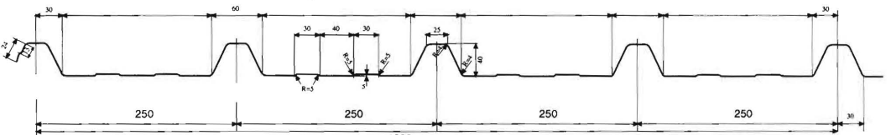

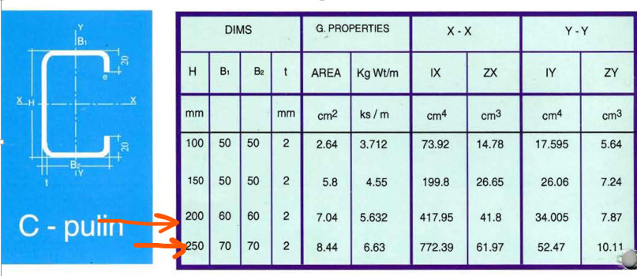**Used purlins :**

**Stairs**

Live Load = 500 kg/m2

Dead load on Carriage = 100 kg/m\

**Steps Calculations :**

Stair width = 2.5 m

stair Tread = 267 mm

stair riser = 167 mm

distributed load on Tread = 0.267m * 0.5t/m2 = 0.134 t/m\

Moment on Tread = 0.134t/m\ * 2.52 / 8 = 0.105 t m

Shear on Tread = 0.17 tons

Use chakkar plates of steel grade 37

Required stiffness = 7.5 cm4

Chakkar plate stiffness of thickness 1 mm = 163 x 0.1 /12 = 34 cm4 -> safe

Using two Bolts to fixing Tread with Angle of Diameters = 10 mm

Stress due to moment = Mx * tp / ( 2 I­­­x ) = 6 Mx / ( tp2 * width ) = 0.105 * 100 / ( 1.22 * (26.7 - 2)) = 1.77 t/cm2  < ( 0.58 * fy = 2.1 t/cm2 ) ……… ok

Stress due to shear = Q / ( tp * width ) = 0.17 / ( 1.2 * ( 26.7 - 2 ) ) = almost zero

**Step Fixation Angle Calculations :**

Bolts construction conditions = 3 * bolts diameter * number of bolts = 60 mm

Welding length = Q / ( allowable weld stress * Sw ) = 0.17 / (0.2 * 5.2 * 0.4 ) = 0.35 cm = 3.5 mm

*Use angle 50*5*5 of length 10 cm*

**Base connection design**

use base plate of 220 x 200 x 10

base load = 2.2 tons

stress on concrete = 2.2 / (22 x 20) = 0.005 ton / cm2 -> safe on concrete bearing

applied moment on plate = 0.005 x 6.252 / 2 = 0.1 ton.cm/cm\

applied stress on plate = 0.1 x 0.5 / ( 1 / 12) = 0.6 tons/cm2 < 3.6 ton/cm2 -> safe

**base welding :**

use minimum weld thickness for base plate = 4 mm

plate length required = 2.2 / ( 0.2 x 5.2 x 0.4 ) + 2 x 0.4 = 6 cm

use minimum weld in both sides of web , 5cm length with 4 mm thickness

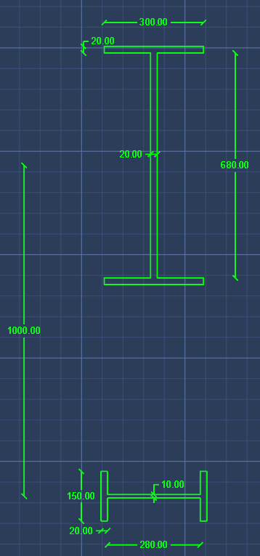**Laced Column Calculations**

centroid:

Y = 76.32cm

X = 16cm

inertia:

Ix = 998867cm4 = 9.99x10E9 mm4 == 10E10mm4

Iy = 26223 cm4 = 2.62x10E8

Area = 372 cm2

ix = 51.8 cm

iy = 8.395cm

Lx (in plane length) = 10m * 2 = 20m = 2000cm ( fixed free )

Ly ( out of plane ) = 870cm ( fixed hinged )

lambda @y = Ly / iy = 103.57cm

lambda @x = 38.6cm

Fcall = 7500 / lambda-squared = 0.7 t/cm2

applied load = 133 + 91 = 224 tons

Fapplied = 0.6 t/cm2 ( safe )

End Gable

Base Design ( calculation for max column loads @ axis A +8m rigth):

Max shear on end gable base = 1.2 tons

Max Normal force = purlins own weigth x columns span x Purlins for column + column o.w + corrugated sheet ow x area

Max Normal force = 5.6 kg/m x ( 9 + 4 ) / 2 x 5 + 0.1t/m x 14m + 5.75 kg/m2 x ( 9 + 4 ) /2 * 10m Max Normal force = 2 tons

use column base steel plate = 15 x 32 cm x 1 cm

Concrete allowable stress = 75 kg/cm2

Applied normal stress = 2 / ( 15 x 32 ) = 0.0042 ton / cm2

Allowable normal force = 15 x 32 x 75 / 1000 = 34 tons ………. Safe

Use Minimum tie rod Diameter , use M20 / 10.9

Rshear = 0.2 x 10.9 x 3.14 x 22 / 4 = 6.8 tons

Rbearing = Diameter x plate thickness x Fu x 0.6 = 2 x 1 x 5.2 x 0.6 = 6.24 tons

Rmin = 6.24 tons ……….. safe

Use minimum weld thickness = 4mm

Use weld in web only -> weld length = ( 20 – 0.8 ) x 2 = 38 cm

Normal stress = 0.0521 ton/cm2 < 1.04 t/cm2 ………..safe

Shear stress = 0.031 t/cm2 < 1.04 t/cm2 ………safe

Combined stresses < 1.1 x 1.04 t/cm2  ………… safe

Moment applied on plate = ( ( plate length – col height ) / 2 ) 2 x stress on concrete = 0.07 t.m/m\

Stress on plate = moment x y / Ix = 0.07 x 0.5 / (1/12) = 0.4 ton/cm2 < 2.4 ton/cm2  -> safe

Gusset plates stiffeners calculations

Buckling limit is L / ix < 16

All gusset plates are with thickness 10 mm

**Without stiffeners** Lallowable = 16 x ix = 16 / ( b x t / ( b x t3 / 12 ) )0.5= 4.5 x t mm = 45 mm

With stiffeners , Lallowable = n x 4.5 x h mm , where n is stiffeners count , h is stiffener height and use stiffener thickness similar to plate thickness 10 mm , neglect plate actions.

use stiffener directly with minimum weld thickness 4mm and minimum weld length 5 cm in both sides